COMPLETE IN-TEXT MANUSCRIPT (assembled 24 May 2026). Tables and figures embedded inline at their cross-reference points. This is the editing surface for the SIR submission. Note: Figure 4 and Figure 5 originally had near-identical captions in the source files — please verify which figure goes in which slot.
Quantifying hidden exploitation: Dual method prevalence estimates of labour exploitation among domestic workers in the United Kingdom

Abstract
Forced labour and labour exploitation are recognised under SDG Target 8.7 as priorities for elimination by 2030, yet the populations affected — undocumented migrant workers, domestic workers, sex workers, agricultural day labourers — are largely invisible to the household surveys on which official social indicators rely. Conventional measurement understates prevalence, often by an order of magnitude, and provides no actionable baseline against which progress toward SDG 8.7 can be assessed. This paper develops and applies a measurement approach that combines respondent-driven sampling (RDS) for ego-level estimation with the network scale-up method (NSUM) for alter-level estimation, allowing the two methods to triangulate prevalence among hidden populations whose true network structure is not directly observable. We apply the approach to UK domestic workers, the hardest realistic case in a developed-economy setting, using a matched-instrument design that produces RDS and NSUM estimates of five comparable ILO-aligned indicators of forced labour. We report per-indicator estimates with bootstrap and Bayesian uncertainty intervals, evaluate sensitivity to the visibility-adjustment factor, and discuss what the divergence between RDS and NSUM estimates implies for quality-of-life monitoring among hidden populations.
Key words
Prevalence estimation; labour exploitation risk; hard-to-reach workers.

- Introduction
As industrial relations scholars, we have been called to rethink our analytical practices and adjust our approach to better reflect transformations in the representation and self-organisation of migrant workers (Alberti and Però, 2018). Member-led civil society and third sector organisations have been described as the ‘new actors’ in the industrial relations of these workers (Alberti and Cutter, 2022). Such organisations work alongside workers and employers to resist any downgrading of employment standards. Central to their endeavors is identification of the nature and scale of employment rights abuses, often discussed in terms of labour exploitation (see for example Kalayaan, 2008; Latin American Women’s Rights Service, 2023). Labour exploitation has been defined as ‘work situations that deviate significantly from standard working conditions as defined by legislation or other binding legal regulations, concerning in particular remuneration, working hours, leave entitlements, health and safety standards and decent treatment’ (European Union for Fundamental Rights, 2015, p. 10). Recently, more serious labour rights abuse has come to the fore with studies in fields such as operations management examining exploitation under the umbrella term ‘modern slavery’ (Gold, Trautrims and Trodd, 2015; New, 2015; Benstead, Hendry and Stevenson, 2018; Stevenson and Cole, 2018). In this article, we use the case of migrant domestic workers in the UK to demonstrate how academics can work with civil society actors representing similarly hard-to-reach workers in this, and other national and sectoral contexts, to make use of prevalence estimators calculated using quantitative methodologies, namely respondent driven sampling and network scale-up methods, to estimate the prevalence and assess the degree of sub-standard employment practices to support their advocacy for immigration policy improvements.
Specific concerns about high levels of exploitation among domestic workers persist in the business ethics and grey literature (Kalayaan, 2008; Mantouvalou, 2016; Varman et al., 2021; Latin American Women’s Rights Service, 2023), yet to our knowledge no-one has yet worked with these organisations to estimate the nature and extent of the risk of labour exploitation and abuse that may exist among domestic workers in the UK. Specifically, this article aims to contribute to a more nuanced understanding of how civil society actors in the UK may engage with quantitative methodologies to improve understanding of the realities of domestic workers’ conditions by demonstrating the use of a statistically robust estimation of the nature and proportion of labour exploitation and abuse.

2. Conceptualising Labour Exploitation and the Degree of Risk
We used the International Labour Organization’s (I.L.O., 2012) ‘Indicators of Forced Labour’ to identify the potential for severe labour exploitation and as a basis for the quantification of our labour exploitation and abuse risk index. The ILO identify eleven indicators designed to help understand how forced labour arises and how it affects victims. These indicators include: abuse of vulnerability; deception; restriction of movement; isolation; physical and sexual violence; intimidation and threats; retention of identity documents; withholding of wages; debt bondage; abusive working and living conditions and excessive overtime. According to the ILO, the presence of a single indicator in any given situation may in some cases imply the existence of forced labour. However, it also suggests that in other cases it may be necessary to look for several indications which, taken together, may point to a case of forced labour. We seek to refine this statement through the construction of a composite index by which means a degree of risk related to the likelihood of a domestic worker experiencing this most severe form of exploitation may be distinguished from the likely occurrence of less severe, though similarly illegal, forms of labour abuse.
The composite risk index we construct is a synthetic indicator in the sense of Mazziotta and Pareto (2013, 2016), aggregating five binary indicators of labour exploitation into a single continuous quality-of-life-relevant measure. The five indicators correspond to formative rather than reflective measurement: an individual is exploited if they are subject to any of these conditions, and the conditions are constitutive rather than reflective of an underlying latent severity (Diamantopoulos and Siguaw 2006; Diamantopoulos et al. 2008). We adopt a non-compensatory weighting scheme in which the presence of any indicator contributes positive weight to the index but no indicator can offset another, consistent with the ILO operational definition of forced labour (ILO 2012, 2017). Polarity is uniform — each indicator has the same direction with respect to the latent construct of exploitation severity. The choice of aggregation follows the guidance of Maggino (2017) and the SIR editorial team (Bartram et al. 2024): we use a weighted-additive index with the five ILO indicators given equal substantive weight (with a 0.35 weight assigned separately to NRM referral, reflecting its diagnostic priority in UK policy practice), and we conduct robustness assessment by perturbing the weights.

2.1 Evaluating the Degree of Risk

In our study, we conceptualise the risk of labour exploitation from the workers’ perspective. We conceive severe forms of labour exploitation such as forced labour as one end of a spectrum ranging from illegal employment practices that constitute labour abuse, such as wage payments below legal minimum wage levels and health and safety violations, through to the likelihood of criminal exploitation recognized in the UK as modern slavery. Our assessment of this personal risk permits a degree of risk to be assigned to various clusters of forced labour indicators with the more indicators present, the stronger the likelihood that the working conditions may be considered exploitative. Along with this novel conceptualization of labour exploitation (LE) as a continuous risk index (or risk score – see ESM_1 for full details of its construction) we also employ a series of dichotomous indicators. These indicators allowed us to operationalise exploitation in two ways. First, we constructed binary indicators classifying respondents as exploited or not exploited, based on threshold criteria. Second, we developed a continuous risk index, designed to capture gradations of vulnerability across the full sample.

Case Setting: Labour Exploitation Risk Among Transnational Migrant Domestic Workers In The UK
Domestic work forms part of a broader industrial category of Personal and Household Service work (PHS). Work in this category includes those employed in ‘social work activities without accommodation’ and ‘activities of households as employers of domestic personnel’ (European Commission, 2012). In 2017, an estimated 980,000 people were engaged in PHS work in the UK (Manoudi et al., 2018). Manoudi et al. (2018) highlight that the PHS sector is dominated by women and migrants, with many undeclared foreign workers. Detailed statistics related to the country of origin of domestic workers migrating to work in PHS in the UK are difficult to isolate before 2019. Since that time, annual migration has fluctuated – falling sharply in 2021 due in part to the COVID-19 pandemic, before later rising again above pre-pandemic levels. In the year to December 2022, the UK Home Office reported that it had issued 18,533 Overseas Domestic Worker visas (Home Office, 2023). These domestic workers came from various countries in South America and Asia, including many from the Philippines.
The grey literature bears testimony to a long history of reports of exploitation in the domestic work sector in the UK. In 2008, the civil society organisation Kalayaan, which was formed to campaign for the formal recognition of migrant domestic workers’ rights in the UK, reported on the impact of proposed changes to the UK immigration system on migrant domestic workers (Kalayaan, 2008). At this stage, new policies, including the development of a specialised visa allowing domestic workers to change employer during their stay were introduced. However, in 2012, these visa conditions were modified, tying domestic workers to a single employer and restricting the length of time that they are permitted to remain in the country to a period of six months (Gower, 2016). Overseas domestic worker visa holders are now, again, permitted to change employers, but not to apply to renew their six-month long visa unless they receive a positive ‘Conclusive Grounds’ decision related to exploitation considered to be modern slavery through the UK’s NRM (Romero and Fisher, 2025). As a result, transnational domestic workers are vulnerable to abuse ranging from minor breaches of employment and health and safety law, to physical and sexual violence, slavery, forced labour and trafficking.
That these conditions may persist is evidenced by a report from another civil society organisation, the Latin American Women’s Rights Service. This report depicts high levels of isolation, exploitation and abuse including a failure by employers to provide written contracts or pay slips; breaches of verbal agreements; a requirement to perform different tasks from those indicated during recruitment; increasing working hours with little or no time off; excessive work days; a lack of paid holiday; many domestic workers not registered with a GP; sexual harassment in the workplace; verbal or physical abuse; employer surveillance; a lack of opportunity to change working conditions; isolation and fear of seeking help; and high reported levels of trafficking for labour exploitation (Latin American Women’s Rights Service, 2023).
Against this backdrop, we worked with civil society organisations to use respondent driven sampling (RDS) as a sampling technique to recruit and survey domestic workers in the UK about the working conditions they were experiencing to estimate the nature and scale of abuse and exploitation based upon reports of their conditions by domestic workers themselves.

3. Materials & Methods
3.1 Study Design and Sampling
Respondent-Driven Sampling (RDS) is a network-based sampling method designed to study hidden or hard-to-reach populations (Heckathorn, 1997, 2011; Gile et al., 2018). It combines chain-referral sampling with a statistical framework to produce population estimates that adjust for network structure and differential recruitment probabilities. The method begins with a set of initial participants (“seeds”), who recruit peers from their social networks. Recruits, in turn, recruit others, creating waves of participation. Each participant reports their network degree (the number of eligible contacts they know), which is used to adjust for selection bias—especially the oversampling of high-degree individuals.
RDS has been widely used to sample hidden populations in public health and social science research (McCreesh et al., 2012; Schwitters, Swaminathan and Serwadda, 2012), and network-based referrals have been described as the only viable method to reach many types of labour trafficking victims (Zhang, 2012). Recent applications include studies of exploitation among low-wage workers in American cities (Bernhardt, Milkman, and N., 2009), labour trafficking in migrant communities (Vincent and Thompson, 2017), child labour in India (Zhang et al., 2019), and commercial sexual exploitation in Nepal (Jordan et al., 2020).
Our approach can best be described as Web-based RDS (Wejnert and Heckathorn, 2008). We designed a web survey using the JISC online survey interface, suitable for respondents to complete via mobile phone. The main survey was conducted over five months between February and July 2023.
Seed Selection and Recruitment
We selected our first wave of participants nonrandomly by convenience sampling. Mobile phone numbers were used both to identify seed participants and to act as a unique identifier for those whom they referred. To avoid sample homophily, original sample members were selected from three distinct domestic worker communities facilitated by civil society organisations. One was an exclusively online community of transnational domestic workers working in the UK, the second represented UK domestic workers of Filipino origin, and the third drew its membership from the Latin American community of domestic workers, also in the UK. Representatives from these organisations, along with other academics with expertise in exploitation within domestic work, contributed to survey question design and facilitated piloting of an initial version of the survey, which was translated and made available in four languages: English, Spanish, Tagalog, and Portuguese.
Incentive Design and Participation Verification
A double incentive scheme rewarded respondents both for completing the questionnaire and for each referral who went on to engage with the survey. The challenge of incentive design is to set the incentive at a level that adequately rewards respondents’ time and participation, but that also avoids the risk of fraudulent participation due to too high a monetary gain (Jordan et al., 2020). A sum of £10 was provided for survey completion with a further £5 for each successful nomination. While respondents were asked to nominate up to 10 domestic workers within their existing social network, participation from up to five of these was requested in subsequent waves. This approach is akin to the use of vouchers in face-to-face studies as advocated by Thompson (2020).

The ethical and practical issues related to the design and effective use of incentives for RDS among vulnerable populations has been much discussed in the literature; see, for example, Wang et al. (2005); Abdul-Quader et al. (2006); Singer and Bossarte (2006); DeJong et al. (2009); Semaan et al. (2009); Brunovskis and Surtees (2010); Semaan (2010); Platt, Luthra, and Frere-Smith (2015), including the specificities of incentive use within web-based surveys (Cobanoglu and Cobanoglu, 2003). Following the principles of lottery use established by Brown, Schonfeld, and Gordon (2006) and Laguilles, Williams, and Saunders (2011), we also designed our survey to encourage the maximum extent of participation by entering all respondents completing the questionnaire into a free prize draw for £150. Research suggests that a high lottery provides the most cost-effective incentive for obtaining complete responses (Gajic, Cameron and Hurley, 2012). While using incentives to encourage participation would seem to be desirable, it is worth noting the potential downside of respondents fabricating responses to increase their remuneration (Robinson, 2014). To minimise this risk, mobile phone numbers for each respondent and those whom they referred were collated, and each of these numbers was called by one of the authors of the paper to ascertain the veracity of the respondent as a migrant domestic worker. The data collection that underpins the analysis presented in this paper was given favourable ethical approval by the lead author’s School Research Ethics Committee in January 2023. All participants were informed about the aims of the study, provided informed consent, and were assured that participation was voluntary and confidential.
3.2 Survey Instrument and Indicators
The survey instrument was designed to capture both egocentric (ego-based) and altercentric (alter-based) network information, enabling the application of both RDS and NSUM estimation methods. Composite measures to quantify the extent to which respondents were at risk of labour exploitation, including severe forms of exploitation such as forced labour, were constructed from existing exploitation typologies, notably the ILO’s Indicators of Forced Labour (I.L.O., 2012).
The survey consisted of 11 composite indicators and included questions related to domestic workers’ level of job satisfaction, employment conditions, and demographic data such as nationality, age, and gender. Based on these indicators, we operationalize exploitation in two ways: (1) five dichotomous (binary) indicators classifying respondents as exploited or not exploited based on threshold criteria, and (2) one continuous risk index designed to capture gradations of vulnerability across the full sample.
Ego-based questions capture respondents’ own experiences of exploitation (used for RDS estimation), while alter-based questions ask respondents to report on the exploitation experiences of domestic workers they know (used for NSUM estimation). See Online Resource ESM_1 and ESM_2 for details of these survey questions and the construction of comparable ego- and alter-based indicators.
3.3 Sample Characteristics
In total, we received completed online surveys from 97 respondents. Twelve participants reported knowing zero domestic workers in the UK—that is, having a null social network—and were excluded from RDS analysis because network degree information is required for RDS weighting procedures. This resulted in an analytical sample of 85 respondents for RDS-based estimation. Although the analytic sample comprises 85 respondents, this is within the range used in comparable respondent-driven sampling (RDS) and network scale-up (NSUM) studies of hidden populations (Gile and Handcock, 2010; Goel and Salganik, 2010; Gile, 2011). Statistical inference in these designs depends not on the absolute sample size but on the structure of the recruitment network, degree distribution, and convergence to equilibrium (Salganik and Heckathorn, 2004). Furthermore, model-assisted and Bayesian RDS estimators (Gile, 2011; Gile et al., 2018) provide valid population estimates even for modest sample sizes, particularly when uncertainty is appropriately quantified through resampling or posterior distributions. In this study, we additionally employ a neighbourhood bootstrap procedure that propagates sampling and network uncertainty, providing robust confidence intervals consistent with small-sample design-based inference (Handcock, Gile and Mar, 2014).
Of the 97 initial respondents, 90 identified themselves as transnational migrants. Forty-five percent regarded themselves as self-employed, 39% identified themselves as employees, and 16% categorised their employment status as that of a worker. The largest single nationality group, comprising 64 respondents (66% of the total), reported a Filipina background. Other nationalities represented included Dominican, Brazilian, Spanish, Colombian, Bolivian, Venezuelan, Cuban, and Panamanian. Female domestic workers made up 97% of the sample, with 3% of the sample comprised of male domestic workers. The age structure of the domestic workers was skewed towards those over 45 years old, with such workers representing over half of the sample (see Table 1).
[Figure 1 inserted below]
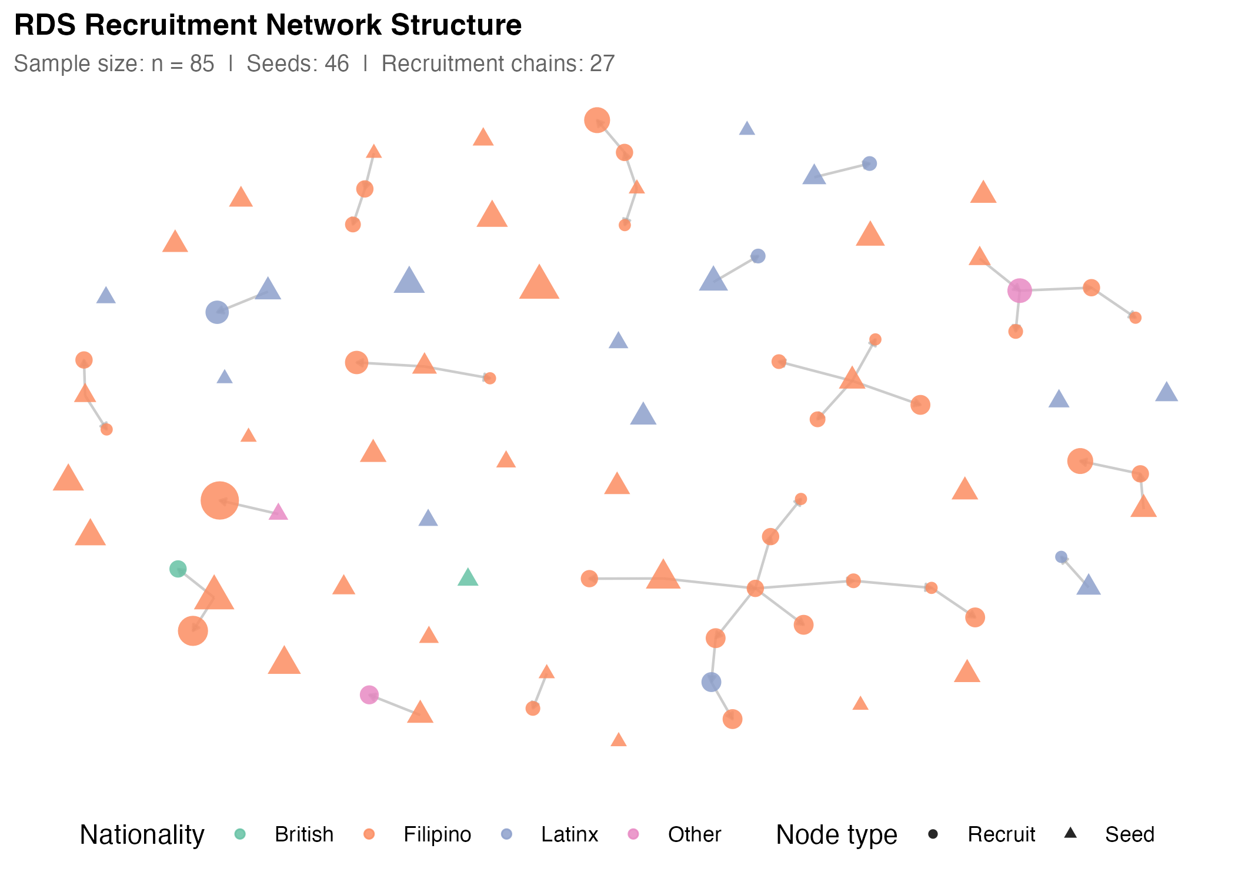
Figure 1. RDS Recruitment Network Structure. Recruitment chains showing seed nodes (triangles) and recruit nodes (circles). Node colours represent nationality clusters; node size is proportional to network degree. Lines show recruiter-recruit relationships. Source: Authors' own work.

[Table 1 inserted below]
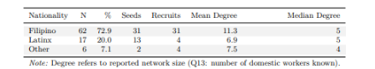
Table 1 RDS Sample Characteristics by Nationality Cluster and Recruitment Wave. Source: Authors’ Own Work.

3.4 Estimation Framework
We analysed the survey sample using multiple estimation models to assess robustness and conduct sensitivity analyses (see ESM_2). The dual structure of our survey instrument—capturing both ego-based and alter-based network information—enables two fundamentally different estimation strategies: Respondent-Driven Sampling (RDS) estimators and Network Scale-Up Methods (NSUM).
To the best of the authors’ knowledge, the combined use of both methods in the same study is rare in peer-reviewed academic research, though it has appeared in government-funded reports and technical documents from NGOs and research organizations (IST Research and University of California, Los Angeles, 2020; Hickman et al., 2025). This paper contributes to the emerging methodological literature on combining RDS and NSUM in survey research for hidden populations. We also developed a novel three-step bootstrap procedure to address uncertainty in NSUM estimates.
RDS Estimation: We implemented three RDS estimators, each with distinct assumptions: RDS-I (Salganik and Heckathorn, 2004), the Volz–Heckathorn (VH) estimator (Volz and Heckathorn, 2008), and Gile’s Successive Sampling (RDS-SS) estimator (Gile, 2011). Given our small sample (85 respondents) and non-negligible sampling fraction, RDS-SS serves as our primary estimator for binary outcomes because it accounts for finite population effects. RDS-I, which performs poorly in small samples and is highly sensitive to seed dependence, is retained as a historical benchmark.
For continuous outcomes such as the exploitation risk index, we employ Model-Assisted (MA-RDS) estimators (Gile and Handcock, 2015). MA-RDS is design-based yet leverages a working Exponential Random Graph Model (ERGM) with degree and homophily terms to approximate inclusion probabilities conditional on observed seeds. This approach directly addresses seed bias and homophily that conventional RDS estimators cannot correct, accommodates finite-population effects through successive-sampling logic, and supports valid estimation of both binary and continuous outcomes. By conditioning on actual seed composition and subgroup structure, the method reduces bias, improves efficiency, and provides design-compatible bootstrap uncertainty (Gile, 2011).
NSUM Estimation: We employ the Modified Basic Scale-Up (MBSU) model (Feehan and Salganick, 2016), which improves upon the original Basic Scale-Up Method by accounting for key sources of bias. The traditional method assumes that respondents can accurately report how many people they know in the hidden population and that all members are equally likely to be known. These assumptions often fail due to stigma, recall issues, or social barriers.
The MBSU addresses this through two primary adjustments. First, the degree ratio adjustment (δ) accounts for differences in network size between the hidden population and frame population. Second, the visibility/true positive rate adjustment (τ) corrects for underreporting of connections to hidden population members due to stigma or lack of awareness. We apply these adjustments with sensitivity analysis across multiple parameter values: δ ∈ {0.8, 0.9, 1.0} and τ ∈ {0.7, 0.85, 1.0}, where δ=1.0 and τ=1.0 represent the unadjusted baseline scenario.
3.5 Comparative Rationale: Ego-Based vs. Alter-Based Inference
RDS and NSUM both exploit social network structures but use fundamentally different information for inference. RDS uses ego-based information: respondents report their own characteristics and network degree, which are combined with recruitment wave to adjust for unequal inclusion probabilities. The underlying logic is that individuals with larger networks are more likely to be recruited, creating bias toward highly connected respondents. RDS estimators explicitly correct for this by weighting observations according to network degree and recruitment path.
NSUM uses alter-based information – respondents serve as informants about the wider hidden population, reporting how many people they know with specific traits. These reports are scaled up using assumptions about network size and visibility to infer prevalence in the broader population. NSUM does not depend on recruitment chains but instead on the accuracy of respondents’ knowledge about others in their social circles.
Applying both methods to the same dataset allows for triangulation across two fundamentally different inferential logics—one anchored in “who recruited whom” (RDS), the other in “how many alters fit this category” (NSUM).
3.6 Bootstrap and Sensitivity Procedures
To appropriately characterise uncertainty in NSUM estimates, we developed a novel three-step bootstrap procedure. This approach resamples respondents, their reported alters, and the exploitation classifications simultaneously, thereby capturing uncertainty at each stage of the inference process. This procedure provides more realistic confidence intervals than those generated by conventional variance estimators, particularly for small samples such as ours. Details of the bootstrap implementation and diagnostic checks are provided in Online Resource ESM_3. Several of the estimation procedures implemented here adopt Bayesian or model-assisted frameworks, which are particularly appropriate for modest sample sizes because they incorporate uncertainty directly into the estimation process (Gile et al., 2018). Our custom neighbourhood bootstrap procedure similarly quantifies uncertainty by repeatedly resampling ego and alter information, producing empirically grounded confidence intervals rather than relying on asymptotic approximations that assume large samples.
For RDS estimators, we employ neighborhood bootstrap methods that preserve the network structure while resampling (Yauck et al., 2022). Sensitivity analyses examine robustness to population size assumptions (50K, 100K, 980K, 1.74M) and NSUM adjustment factor values. Full results are reported in Online Resource ESM_4.
3.7 Use of AI
Large Language Models (LLMs) were used for brainstorming the organization of the paper and some textual editing. Code co-pilot (Claude Code) was used to test and debug R scripts employed in the statistical analysis. No generative models were used to generate or simulate data.

4. Results
4.1 Descriptive Overview
Sample characteristics are presented in Table 1 and Fig1. In total, 97 respondents completed the survey, of whom 85 had non-zero network degree and were included in RDS analysis. The analytical sample comprised 90 transnational migrants (93%), with the largest nationality cluster being Filipino (66%). Female domestic workers constituted 97% of the sample, with over half aged 45 or older. Self-employment status was reported by 45% of respondents.
4.2 Model-Assisted Estimates of the Continuous Risk Index
One of the central contributions of this study is the introduction of a continuous risk index to measure degrees of exposure to labour exploitation. The index was constructed from multiple indicators aligned with the ILO’s forced labour framework, weighted inductively and refined through expert consultation. Rather than treating exploitation as a dichotomy, the risk index conceptualises all domestic workers as facing some degree of potential exploitation, albeit with significant variation in intensity.
Because continuous traits cannot be estimated directly with conventional RDS estimators or NSUM, we employed model-assisted inference methods (Gile and Handcock, 2015). These methods adjust for the non-random structure of RDS recruitment while permitting reliable estimation of means and distributions of continuous outcomes.
[Figure 2 inserted below]
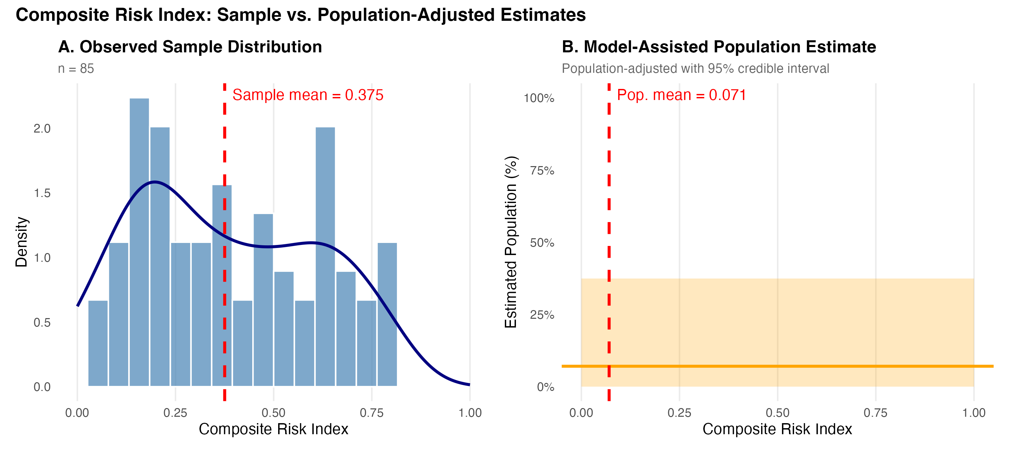
Figure 2. Composite Risk Index: Sample vs. Population-Adjusted Estimates. Panel A shows the empirical distribution of the composite risk index in the observed RDS sample (n=85), with the sample mean marked. Panel B shows the Model-Assisted (MA) population estimate with its 95% credible interval, adjusted for RDS sampling bias. Source: Authors' own work.

Figure 2 presents the comparison between the observed sample distribution and the model-assisted population estimates, demonstrating how the bias correction affects our understanding of exploitation risk in the broader domestic worker population. The population-weighted average risk is \(0.0124\) This represents the Model-Assisted estimate of mean exploitation risk in the population, adjusted for RDS sampling bias. It is a design-based estimate that corrects for the non-random recruitment process in RDS. The population-adjusted distribution shows less concentration in the lower risk values compared to the raw sample. The MA estimate suggests that \(~7.2\%\) of DWs in the UK have moderate risk (0.1725) This pattern reinforces the conceptual claim that exploitation is best understood as a continuum rather than a simple binary condition.
4.3 Binary Exploitation Indicators: Comparative RDS–NSUM Estimates
To complement the continuous measure, we operationalised exploitation as binary outcomes. Respondents were classified as exploited if they met threshold indicators consistent with ILO definitions. We present prevalence estimates from three approaches: (1) Model-Assisted (MA-RDS) Bayesian estimates that adjust for RDS sampling bias, (2) frequentist RDS estimators (RDS-I and RDS-SS) for comparison, and (3) Network Scale-Up Method (NSUM) estimates with multiple adjustment factor scenarios.
Figure 3 provides a comprehensive comparison of prevalence estimates across all three approaches. While absolute values differ—reflecting the fundamental differences between ego-based (RDS) and alter-based (NSUM) inference—the overall pattern is remarkably stable. Excessive hours consistently shows the highest prevalence across all methods, followed by threats/abuse and pay-related issues. Model-Assisted estimates generally fall between RDS frequentist estimates and NSUM baseline estimates, though NSUM estimates are highly sensitive to adjustment factor assumptions.
[Figure 3 inserted below]
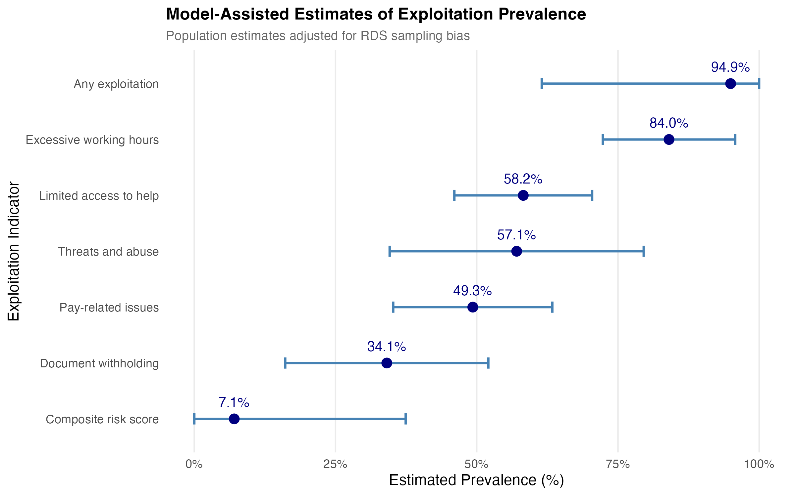
Figure 3. Model-Assisted Estimates of Exploitation Prevalence. Population prevalence estimates with 95% credible intervals for each exploitation indicator, ordered by prevalence magnitude. Posterior intervals are from Bayesian Model-Assisted inference (Gile & Handcock, 2015) at N=50,000 with seed.selection='degree'. Source: Authors' own work.
4.4 Model-Assisted Bayesian Estimates

[Table 2 inserted below]
Table 2 Model-Assisted Estimates of Binary Exploitation Indicators: Population prevalence estimates adjusted for RDS sampling bias. Values represent the estimated proportion of domestic workers experiencing each form of exploitation. Source: Authors’ Own Work
Exploitation Indicator | Population Prevalence (95% CrI)
Any Exploitation | 95.0% (62.2-100.0%)
Excessive Hours | 83.7% (71.9-95.6%)
Limited Access to Help | 58.3% (46.1-70.6%)
Threats/Abuse | 57.3% (35.4-79.3%)
Pay-Related Issues | 49.5% (35.6-63.5%)
Document Withholding | 34.3% (16.4-52.2%)
Note: Estimates adjusted for RDS sampling bias using Bayesian Model Assisted Inference of Gile & Handcock (2015) (N=980,000, sample seed selection). Credible intervals from posterior distribution.

[Figure 4 inserted below]
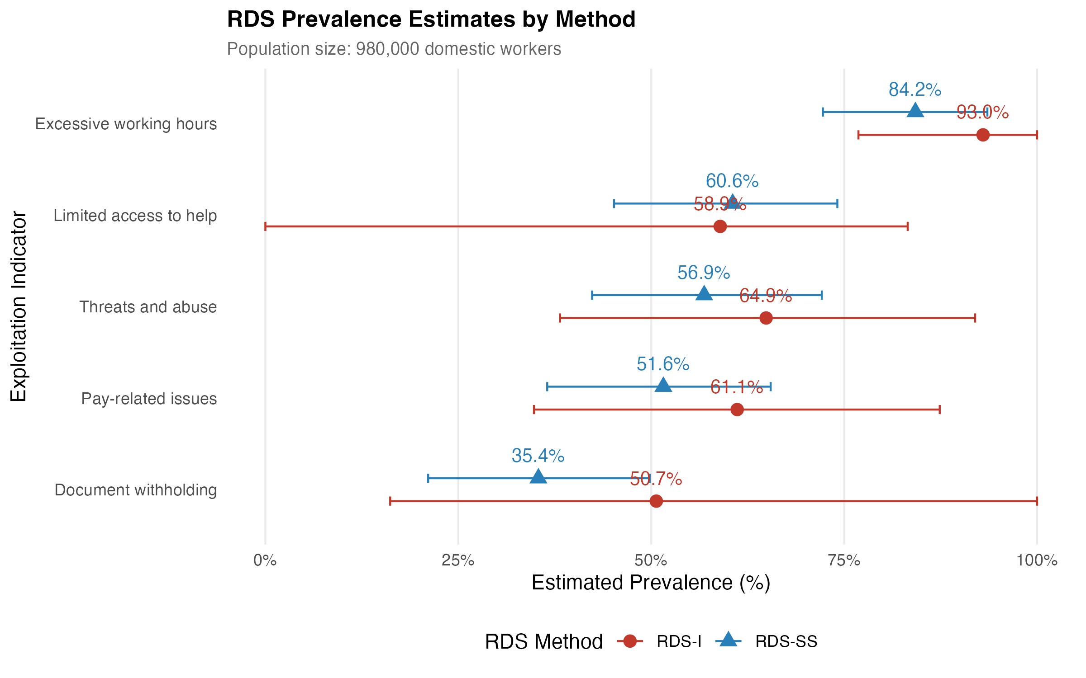
Figure 4. RDS Prevalence Estimates by Method (RDS-I vs RDS-SS). Point estimates and per-method bootstrap 95% confidence intervals for the five binary exploitation indicators at N=980,000 domestic workers. RDS-I (Salganik-Heckathorn) shown in red; RDS-SS (Gile's Successive Sampling) shown in blue. Source: Authors' own work.

4.5 Frequentist RDS Estimates

[Table 3 inserted below]
Table 3 RDS Estimates of Binary Exploitation Indicators: Comparison of RDS-I and RDS-SS estimators with neighbourhood bootstrap confidence intervals (N=980,000). Source: Authors’ Own Work
Exploitation Indicator | RDS-I | RDS-SS
Document withholding | 49.4% (25.3–56.3) | 34.2% (25.2–56.0)
Excessive working hours | 92.8% (71.4–92.9) | 83.7% (71.5–93.0)
Limited access to help | 57.7% (55.1–80.3) | 59.4% (54.7–80.2)
Pay-related issues | 59.3% (34.2–63.5) | 49.7% (34.8–63.4)
Threats and abuse | 65.2% (40.5–72.1) | 57.2% (40.1–72.3)
Note: RDS-I: Salganik-Heckathorn estimator. RDS-SS: Gile's Successive Sampling estimator. Confidence intervals from neighbourhood bootstrap (n=1000). Population size: 980,000 domestic workers.

[Figure 5 inserted below]
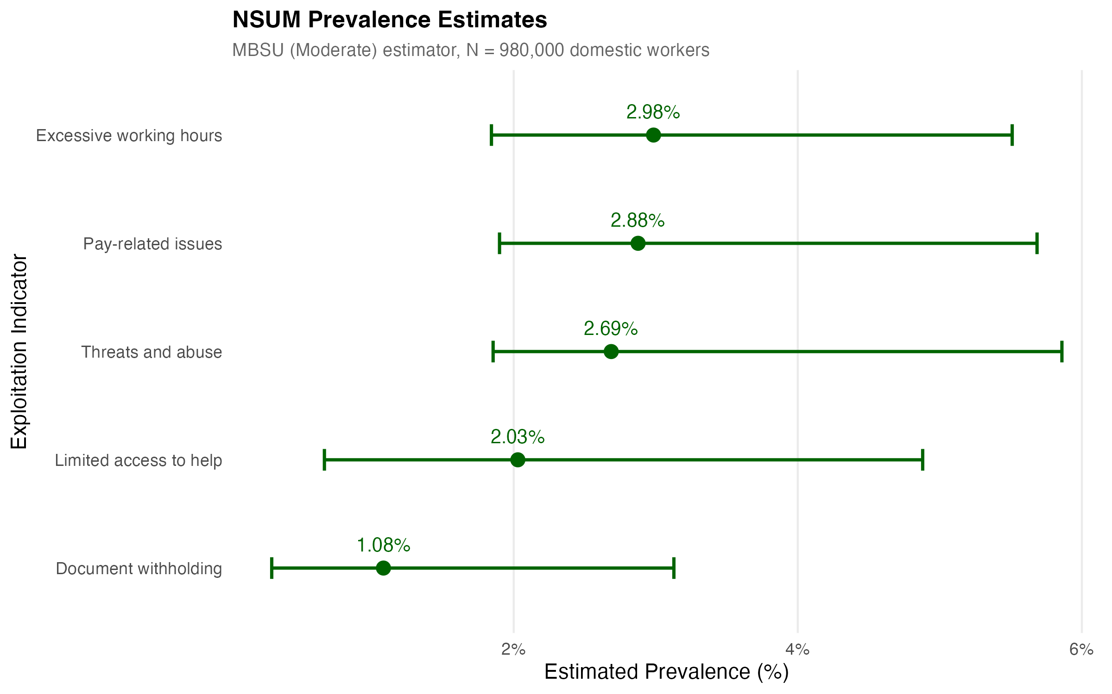
Figure 5. NSUM Prevalence Estimates. Modified Basic Scale-Up (MBSU, Moderate adjustment) estimator with neighbourhood-bootstrap 95% confidence intervals for the five binary exploitation indicators at N=980,000 domestic workers. Source: Authors' own work.

4.6 Network Scale-Up Method (NSUM) Estimates
Using the Modified Basic Scale-Up (MBSU) estimator (Feehan and Salganick, 2016) with Sequential Sampling weights and a UK domestic worker population of 980,000, Table 4 presents prevalence estimates under three adjustment scenarios: (1) unadjusted baseline (δ=1.0, τ=1.0), (2) moderate adjustments (δ=0.9, τ=0.85), and (3) conservative adjustments (δ=0.8, τ=0.7).
NSUM estimates show substantial sensitivity to adjustment factor assumptions. Unadjusted estimates range from 0.83% (document withholding) to 2.28% (excessive hours). Conservative adjustments accounting for network degree differences and visibility barriers produce estimates approximately 1.8 times higher—ranging from 1.48% to 4.08%—while moderate adjustments yield intermediate values approximately 1.3 times the baseline. Wide confidence intervals reflect substantial uncertainty inherent in network-based estimation methods, particularly for small hidden populations.
[Table 4 inserted below]
Table 4 NSUM Prevalence Estimates for Labour Exploitation Indicators: Estimates using Modified Basic Scale-Up (MBSU) method with Sequential Sampling weights and population size of 980,000 domestic workers. Adjustment factors: \(\delta\) (δ, degree ratio) controls for network size differences; \(\tau\) (τ, visibility/true positive rate) controls for reporting accuracy and visibility barriers. Bootstrap confidence intervals based on neighbourhood resampling (B=1000). Source: Authors’ Own Work.
Adjustment Method | Outcome | Point Estimate | 95% CI Lower | 95% CI Upper | Prevalence (%)
No Adjustment (δ=1.0, τ=1.0)
MBSU (Conservative) | Access to Help | 27,164.671 | 8,933.933 | 65,323.13 | 2.77% (0.91% - 6.67%)
MBSU (Conservative) | Document Withholding | 14,500.488 | 3,968.605 | 41,872.57 | 1.48% (0.40% - 4.27%)
MBSU (Conservative) | Excessive Hours | 39,955.494 | 24,677.066 | 73,760.07 | 4.08% (2.52% - 7.53%)
MBSU (Conservative) | Pay Issues | 38,499.114 | 25,438.688 | 76,102.17 | 3.93% (2.60% - 7.77%)
MBSU (Conservative) | Threats/Abuse | 35,966.277 | 24,834.407 | 78,445.77 | 3.67% (2.53% - 8.00%)
Conservative (δ=0.8, τ=0.7)
MBSU (Moderate) | Access to Help | 19,885.249 | 6,539.872 | 47,818.24 | 2.03% (0.67% - 4.88%)
MBSU (Moderate) | Document Withholding | 10,614.737 | 2,905.123 | 30,651.82 | 1.08% (0.30% - 3.13%)
MBSU (Moderate) | Excessive Hours | 29,248.467 | 18,064.258 | 53,994.30 | 2.98% (1.84% - 5.51%)
MBSU (Moderate) | Pay Issues | 28,182.358 | 18,621.784 | 55,708.78 | 2.88% (1.90% - 5.68%)
MBSU (Moderate) | Threats/Abuse | 26,328.255 | 18,179.435 | 57,424.35 | 2.69% (1.86% - 5.86%)
Moderate (δ=0.9, τ=0.85)
MBSU (No Adjustment) | Access to Help | 15,212.216 | 5,003.002 | 36,580.95 | 1.55% (0.51% - 3.73%)
MBSU (No Adjustment) | Document Withholding | 8,120.274 | 2,222.419 | 23,448.64 | 0.83% (0.23% - 2.39%)
MBSU (No Adjustment) | Excessive Hours | 22,375.077 | 13,819.157 | 41,305.64 | 2.28% (1.41% - 4.21%)
MBSU (No Adjustment) | Pay Issues | 21,559.504 | 14,245.665 | 42,617.22 | 2.20% (1.45% - 4.35%)
MBSU (No Adjustment) | Threats/Abuse | 20,141.115 | 13,907.268 | 43,929.63 | 2.06% (1.42% - 4.48%)
Note: MBSU = Modified Basic Scale-Up method; δ = degree ratio (d̄_H,F/d̄_F,F, ratio of hidden population network degree to frame population degree); τ = visibility/true positive rate (v̄_H,F/d̄_H,F, proportion of edges correctly reported, measures transmission and reporting accuracy); Bootstrap method: neighbourhood resampling with 1000 iterations; Population base: 980,000 UK domestic workers.

4.7 Robustness Checks
A series of robustness checks were performed to assess the stability of the findings. In ESM3, a comprehensive analysis comparing all prevalence estimates across indicators, methods, and parameter values is presented. There, remarkable consistency is demonstrated across different analytical approaches. The pattern of estimates is remarkably stable across methods, with excessive hours consistently showing the highest prevalence, followed by threats/abuse and pay-related issues, while document withholding shows more moderate prevalence levels. This cross-method validation strengthens confidence in our findings and demonstrates the robustness of the dual estimation approach. Full technical details are reported in Online Resource ESM_3 and ESM_4.

5. Discussion
5.1 Summary of Findings
In this study we worked with civil society organisations representing domestic workers to estimate the prevalence of labour exploitation among domestic workers in the UK using both Respondent-Driven Sampling (RDS) and Network Scale-Up Method (NSUM). We introduced a continuous risk index alongside binary exploitation indicators based on ILO forced labour criteria. Model-Assisted RDS estimates suggest prevalence rates ranging from 34% to 84% for various exploitation indicators among respondents. While the analytic sample comprises 85 respondents, RDS estimators are design-based and adjust for network degree and recruitment patterns, enabling valid population inference even in modest samples where conventional random sampling is infeasible. In contrast, NSUM estimates—highly sensitive to adjustment factors—range from 0.83% to 4.08% depending on assumptions about network degree differences (δ) and visibility/reporting accuracy (τ). The range of 34% to 84% prevalence using RDS estimators represents variation across distinct exploitation indicators, each corresponding to a different forced labour dimension (e.g., pay withholding, intimidation, excessive hours). It should not be interpreted as statistical uncertainty for a single prevalence measure. The pattern across methods is remarkably consistent: excessive working hours shows the highest prevalence, followed by threats/abuse and pay-related issues, while document withholding shows more moderate levels. Robustness checks across different population size assumptions and estimation approaches confirm the stability of these relative patterns.
5.2 Methodological Reflections and Contributions
This paper makes three contributions to the social-indicators literature. First, it develops a dual ego/alter survey instrument that yields directly comparable RDS and NSUM estimates of five ILO-aligned labour-exploitation indicators, addressing a long-standing measurement gap noted by the ILO (2017, 2022) in which RDS-derived estimates rely on respondent self-report whereas NSUM-derived estimates rely on respondents' reports about others. Second, it implements a three-step bootstrap inference procedure for NSUM estimates of multiple indicators in a hidden population, propagating uncertainty from network-size estimation, alter-count estimation and visibility-adjustment in a single re-sampling scheme. Third, it shows how the divergence between RDS and NSUM estimates can be read diagnostically — as evidence about the visibility of different exploitation behaviours within the workers' personal networks — rather than as a single 'best' point estimate, and proposes a continuous risk index that integrates the five indicators into a single quality-of-life-relevant social indicator for hidden vulnerable populations. The UK domestic-worker case demonstrates the approach in the hardest realistic setting; the methodology generalises to other hidden populations relevant to SDG 8.7 monitoring.
Dual conceptualisation of exploitation: We introduce two distinct approaches to operationalising exploitation. First, we treat exploitation as a binary outcome (exploited versus not exploited), enabling direct comparison of prevalence estimates across RDS and NSUM methods. Second, we construct a continuous risk index, acknowledging that all domestic workers may be exposed to some degree of exploitation risk. To our knowledge, this is the first application of model-assisted RDS estimators to quantify a continuous measure of exploitation risk.
Combining RDS and NSUM on the same survey instrument: By designing a survey that captures both ego and alter information, we are able to apply RDS and NSUM to the same sample. This dual approach has rarely been implemented in studies of labour exploitation. It provides an opportunity to cross-validate results and assess the robustness of prevalence estimates. While the analytic sample is modest, the use of Bayesian and design-based network estimators ensures statistical validity under conditions typical of hidden-population research. The combination of RDS and NSUM methods allows for robust inference even with limited respondent counts, as uncertainty is explicitly modelled and propagated through our neighbourhood bootstrap approach. Importantly, the variation across indicators (34–84%) represents true heterogeneity in the forms of exploitation experienced by domestic workers rather than measurement error.
Novel bootstrap procedure for NSUM: Recognising the non-random nature of an RDS sample, we developed a three-step bootstrap procedure tailored for NSUM estimation. This resamples respondents, recalculates weights, and re-estimates NSUM prevalence at each iteration. The procedure captures multiple layers of uncertainty and produces more reliable confidence intervals than conventional methods, particularly in small samples.
Application to domestic workers in the UK: Finally, by working with civil society organisations to apply these methods to a population that is both highly stigmatised and under-researched, we demonstrate the feasibility of using advanced network-based estimation techniques in contexts where traditional sampling is impossible. This methodological innovation has potential applications in studies of other hidden labour markets and vulnerable populations.
5.3 Interpreting RDS–NSUM Divergence: The Role of Visibility
Substantial discrepancies between hidden population prevalence estimates derived from Respondent-Driven Sampling (RDS) and the Network Scale-Up Method (NSUM) are widely observed in empirical research and simulation studies. In the present case, for example, egocentric RDS-based estimates suggest that 34% to 84% of respondents personally experienced indicators of exploitation. In contrast, the corresponding NSUM estimates suggest that only 2.9% to 5.1% of the general domestic worker population experiences these same harms. This stark divergence—often approaching an order of magnitude—warrants a careful methodological explanation.
Among the various sources of error affecting NSUM, the most important and widely documented is visibility bias, also referred to in some literature as transmission bias. Visibility refers to the extent to which members of a hidden population are known to belong to that population by members of the general population. In the context of NSUM, visibility determines whether a respondent can accurately report having connections to members of the hidden group. If visibility is low—because of stigma, secrecy, or lack of awareness—respondents will systematically underreport these ties. This causes a downward bias in the numerator of the NSUM estimator, thereby underestimating the size of the hidden population.
In our setting, where RDS estimates suggest that over 50% of respondents have experienced some form of labour exploitation, but NSUM estimates suggest only 3–5% of the domestic worker population does so, visibility bias is almost certainly the dominant factor explaining the discrepancy. This is especially true in contexts involving exploitation, abuse, or trafficking—where group membership is often concealed both by victims and by observers. Respondents in the frame population may simply be unaware that their contacts are experiencing exploitation, leading to substantial underreporting.
Hence, visibility bias is a major and well-understood limitation of NSUM, and likely the principal reason why our NSUM estimates are substantially lower than those derived from RDS. The use of RDS-based estimators, particularly those that adjust for sample design such as Gile’s SS estimator, provides direct measurement of traits among the hidden population and avoids the visibility problem. Therefore, RDS estimates are often more accurate in estimating prevalence within the hidden population, whereas NSUM estimates are typically biased downward unless adjusted for visibility and related biases.
5.4 Policy and Theoretical Implications
These transnational migrants are at particular risk of exploitation due to regulatory visa restrictions and intersecting structural issues related to their gender, the relative isolation of domestic work and a lack of supportive social networks. Workers enter on restricted visas where their employment—and their right to remain in the country—is tied to their continuing employment. This can mean that they fall out of legal migratory status. Due to the social stigma attached to such illegal working, transnational workers remaining in the UK without the right to work may be considered a hidden, hard-to-reach, population. Yet the UK Government has proved reluctant to respond to calls to remove the restrictive, tied, visa conditions currently in force for those migrant workers working in the UK on the Overseas Domestic Workers visa (Gower, 2016). Maintaining these restrictive conditions prevents the ratification in the UK of C189, the International Convention for Domestic Workers (ILO, 2011). If the estimates resulting from our study are correct, these visa conditions place migrant domestic workers at significant risk of serious forms of labour exploitation including, in its most severe form, exploitation that exhibits the characteristics of forced labour—legally considered a form of modern slavery.
To reduce the vulnerability of transnational domestic workers to this—and other—forms of labour exploitation, we urge policy-makers to reconsider these discriminatory visa conditions and offer the same freedoms to domestic workers that are enjoyed by other groups of workers under UK law.
In addition, given the vulnerabilities experienced by workers due to the private nature of the workplace, we would urge the UK government to consider the regulation of domestic worker employers.
Finally, given the stigma and very real danger of deportation of those transnational migrant domestic workers who may have fallen out of legal migration status, our evidence suggests that there is an urgent need for the UK Government to enforce a firewall between immigration control and labour exploitation if the true scale of abuse is to be made visible and the perpetrators brought to justice.
The UK Visa and Immigration service already offers rights-based training to migrant domestic workers via UK embassies in certain source countries. To reduce migrant domestic workers’ vulnerabilities, we advocate the expansion of this training both to include explicit training related to employment and labour rights within the UK and to the rapidly expanding range of new source countries from where migrant domestic workers are now drawn.
5.5 Limitations and Directions for Future Research
As with any empirical research, our study is subject to limitations. In terms of nationality, our sample is not representative of the demographics of those domestic workers employed on Overseas Domestic Worker Visas in 2022 the UK. Due to the increasing number of workers on Overseas Domestic Work visas from the Indian sub-continent, attempts were made also to seed respondents from this community. This proved difficult, with anecdotal information suggesting that domestic workers from this community rarely had access to a personal mobile phone. It is not therefore possible to infer the nature and extent of labour exploitation within this sub-section of the domestic worker population.
As the network structure of our sample demonstrates, even with a well-designed incentive scheme it proved difficult to recruit respondents from these communities of domestic workers in subsequent sampling waves in the time available. Most of our respondents are therefore original sample members draw from the three domestic worker communities used to seed the survey. Although the absolute sample size is small, RDS and NSUM derive their statistical power from network structure rather than sample count, providing design-consistent population estimates under the stated assumptions.
We believe that web-RDS combined with statistical estimators such as NSUM offers an important method for the capture and comparison of relative proportions of labour exploitation and abuse by civil society actors in sectors within and beyond the UK. Network scale up methods, and potential enhancements such as Generalised network scale up estimators offer to enhance understanding, not least within operations and supply chain management research, of the extent of labour exploitation in different sectors and across industries. The differences in NSUM and RDS estimates warrants further investigation and suggests research into combining multiple estimates may be a fruitful direction in human rights research and especially prevalence of modern slavery research.

6. Conclusion
This article examines original quantitative data collected with the help of civil society actors from domestic workers based in the UK to measure and assess the nature and prevalence of labour exploitation among this vulnerable population. Our contribution lies in the presentation of two different statistical estimators based upon RDS and NSUM techniques and the construction of both binary and composite risk indices from indicators recognised by the International Labour Organization. In so doing, we shed new light on how quantitative methods may be used to assess the nature and extent of labour exploitation risk among these and other such vulnerable hard-to-reach workers, who typically enter their destination countries on restricted visas, in their advocacy for decent work. The results of our analysis raise important questions for both theory and practice about the range and accuracy of the estimates that it is possible to generate using these statistical techniques. Meaningful and trustworthy estimates of labour exploitation among such vulnerable groups are required if civil society actors are to convince policymakers to make sensitive decisions about policy adjustments and the allocation of scarce resources to ensure entrants, such as those entering the UK labour market, experience decent working conditions. We believe our study opens the way for further transdisciplinary research on the efficacious use of statistical estimators to measure the size of hidden populations of exploited, hard-to-reach, workers and the identification of appropriate means to quantify the extent of labour exploitation experienced.

References
Abdul-Quader, A.S. et al. (2006) ‘Effectiveness of respondent-driven sampling for recruiting drug users in New York City: findings from a pilot study’, Journal of Urban Health, 83(3), pp. 459–76.
Alberti, G. and Cutter, J. (2022) ‘Labour migration policy post-Brexit: The contested meaning of regulation by old and new actors’, Industrial Relations Journal, 53(5), pp. 430–445. Available at: https://doi.org/10.1111/irj.12382.
Alberti, G. and Però, D. (2018) ‘Migrating Industrial Relations: Migrant Workers’ Initiative Within and Outside Trade Unions’, British Journal of Industrial Relations, 56(4), pp. 693–715. Available at: https://doi.org/10.1111/bjir.12308.
Benstead, A.V., Hendry, L.C. and Stevenson, M. (2018) ‘Horizontal collaboration in response to modern slavery legislation: An action research project’, International Journal of Operations &amp; Production Management, 38(12), pp. 2286–2312. Available at: https://doi.org/10.1108/IJOPM-10-2017-0611.
Bernhardt, A., Milkman, R.T., and N. (2009) Broken laws, unprotected workers: Violations of employment and labor laws in america’s cities. UCLA IRLE Report.
Brown, J.S., Schonfeld, T.L. and Gordon, B.G. (2006) ‘You may have already won...”: An examination of the use of lottery payments in research’, IRB: Ethics & Human Research, 28(1), pp. 12–16.
Brunovskis, A. and Surtees, R. (2010) ‘Untold stories: biases and selection effects in research with victims of trafficking for sexual exploitation’, International Migration, 48(4), pp. 1–37.
Cobanoglu, C. and Cobanoglu, N. (2003) ‘The effect of incentives in web surveys: application and ethical considerations’, International Journal of Market Research, 45(4), pp. 1–13.
DeJong, J. et al. (2009) ‘Ethical considerations in HIV/AIDS biobehavioral surveys that use respondent-driven sampling: illustrations from Lebanon’, American Journal of Public Health, 99(9), pp. 1562–1567.
European Commission (2012) ‘Staff Working Docuemnt on exploitating the employment potential of the personal and household services, SWD (2012) final’.
European Union for Fundamental Rights (2015) ‘Severe labour exploitation: workers moving within or into the European Union’. Available at: https://doi.org/10.1163/2210-7975_HRD-9992-2016018.
Feehan, D.M. and Salganick, M.J. (2016) Generalizing the Network Scale-up Method: A New Estimator for the Size of Hidden Populations - Dennis M. Feehan, Matthew J. Salganik, 2016. Available at: https://journals.sagepub.com/doi/10.1177/0081175016665425 (Accessed: 12 March 2024).
Gajic, A., Cameron, D. and Hurley, J. (2012) ‘The cost-effectiveness of cash versus lottery incentives for a web-based, stated-preference community survey’, The European Journal of Health Economics, 13(6), pp. 789–799.
Gile, K.J. (2011) ‘Improved Inference for Respondent-Driven Sampling Data With Application to HIV Prevalence Estimation’, Journal of the American Statistical Association, 106(493), pp. 135–146. Available at: https://doi.org/10.1198/jasa.2011.ap09475.
Gile, K.J. et al. (2018) ‘Methods for inference from respondent-driven sampling data’, Annual Review of Statistics and Its Application, 5(1), pp. 65–93. Available at: https://doi.org/10.1146/annurev-statistics-031017-100704.
Gile, K.J. and Handcock, M.S. (2010) ‘Respondent-Driven Sampling: An Assessment of Current Methodology’, Sociological Methodology, 40(1), pp. 285–327. Available at: https://doi.org/10.1111/j.1467-9531.2010.01223.x.
Gile, K.J. and Handcock, M.S. (2015) ‘Network Model-Assisted Inference from Respondent-Driven Sampling Data’, Journal of the Royal Statistical Society. Series A, (Statistics in Society), 178(3), pp. 619–639. Available at: https://doi.org/10.1111/rssa.12091.
Goel, S. and Salganik, M.J. (2010) ‘Assessing respondent-driven sampling’, Proceedings of the National Academy of Sciences, 107(15), pp. 6743–6747. Available at: https://doi.org/10.1073/pnas.1000261107.
Gold, S., Trautrims, A. and Trodd, Z. (2015) ‘Modern slavery challenges to supply chain management’, Supply Chain Management: An International Journal, 20(5), pp. 485–494. Available at: https://doi.org/10.1108/SCM-02-2015-0046.
Gower, M. (2016) ‘Calls to change overseas domestic worker visa conditions’. Available at: https://researchbriefings.files.parliament.uk/documents/SN04786/SN04786.pdf.
Handcock, M.S., Gile, K.J. and Mar, C.M. (2014) ‘Estimating hidden population size using Respondent-Driven Sampling data’, Electronic Journal of Statistics, 8(1), pp. 1491–1521. Available at: https://doi.org/10.1214/14-EJS923.
Heckathorn, D.D. (1997) ‘Respondent-Driven Sampling: A New Approach to the Study of Hidden Populations’, Social Problems, 44(2), pp. 174–199. Available at: https://doi.org/10.2307/3096941.
Heckathorn, D.D. (2011) ‘Comment: Snowball versus respondent-driven sampling’, Sociological Methodology, 41(1), pp. 355–366.
Hickman, S. et al. (2025) Human Trafficking Prevalence Estimation Feasibility Study | Bureau of Justice Statistics. Available at: https://bjs.ojp.gov/library/publications/human-trafficking-prevalence-estimation-feasibility-study (Accessed: 19 December 2025).
Home Office (2023) ‘Why do people come to the UK to work?’ Available at: https://www.gov.uk/government/statistics/immigration-system-statistics-year-ending-june-2023/why-do-people-come-to-the-uk-to-work.
ILO (2011) C189 - Domestic Workers Convention, 2011 (No. 189). Available at: https://normlex.ilo.org/dyn/nrmlx_en/f?p=NORMLEXPUB:55:0::NO::P55_TYPE%2CP55_LANG%2CP55_DOCUMENT%2CP55_NODE:SUP%2Cen%2CC189%2C%2FDocument (Accessed: 19 December 2025).
I.L.O. (2012) ‘ILO indicators of forced labour’. Available at: https://www.ilo.org/global/topics/forced-labour/publications/WCMS_203832/lang--en/index.htm.
IST Research and University of California, Los Angeles (2020) Estimating the Prevalence of Child Sex Trafficking in Mahashtra, India. Technical Report. Global Fund to End Modern Slavery.
Jordan, L. et al. (2020) ‘Overcoming methodological challenges in prevalence studies in developing contexts with vulnerable children’, International Social Work, 63(3), pp. 371–385.
Kalayaan (2008) ‘The new bonded labour?’ Available at: http://www.kalayaan.org.uk/documents/Kalayaan%20Oxfam%20report.pdf.
Laguilles, J.S., Williams, E.A. and Saunders, D.B. (2011) ‘Can lottery incentives boost web survey response rates? Findings from four experiments’, Research in Higher Education, 52(5), pp. 537–553.
Latin American Women’s Rights Service (2023) ‘Behind closed doors: Experiences of Latin American domestic workers in the UK’. Available at: https://lawrs.org.uk/wp-content/uploads/2023/08/Behind-closed-doors_domestic_work.pdf.
Manoudi, A. et al. (2018) An analysis of Personal and Household Services to support work life balance for working parents and carers - Google Search. Synthesis Report ECE Thematic Review. European Commission. Available at: https://www.google.com/search?q=An+analysis+of+Personal+and+Household+Services+to+support+work+life+balance+for+working+parents+and+carers&rlz=1C1GCEB_enGB932GB935&oq=An+analysis+of+Personal+and+Household+Services+to+support+work+life+balance+for+working+parents+and+carers&gs_lcrp=EgZjaHJvbWUyBggAEEUYOdIBCDIzNjNqMGo3qAIAsAIA&sourceid=chrome&ie=UTF-8 (Accessed: 28 October 2024).
Mantouvalou, V. (2016) ‘Modern slavery? The UK visa system and the exploitation of migrant domestic workers’, in British politics and policy at LSE. Available at: https://blogs.lse.ac.uk/politicsandpolicy/exploitation-of-migrant-domestic-workers-in-the-uk/.
McCreesh, N. et al. (2012) ‘Evaluation of respondent-driven sampling’, Epidemiology, 23(1), pp. 138–147. Available at: https://www.jstor.org/stable/23214188 (Accessed: 25 April 2023).
New, S.J. (2015) ‘modern slavery and the supply chain: the limits of corporate social responsibility?’, Supply Chain Management, 20(6), pp. 697–707. Available at: https://doi.org/10.1108/SCM-06-2015-0201.
Platt, L., Luthra, R. and Frere-Smith, T. (2015) ‘Adapting chain referral methods to sample new migrants: Possibilities and limitations’, Demographic Research, 33, pp. 665–700.
Robinson, O.C. (2014) ‘Sampling in interview-based qualitative research: A theoretical and practical guide’, Qualitative research in psychology, 11(1), pp. 25–41.
Romero, A. and Fisher, O. (2025) ‘Blueprint for safer and fairer migration for low-paid work’. Focus on Labour Exploitation. Available at: https://labourexploitation.org/app/uploads/2025/06/Flex-Report-Blueprint-for-safer-and-fairer-migration-for-low-paid-work_final_30_June-.pdf (Accessed: 11 July 2025).
Salganik, M.J. and Heckathorn, D.D. (2004) ‘5. Sampling and Estimation in Hidden Populations Using Respondent-Driven Sampling’, Sociological Methodology, 34(1), pp. 193–240. Available at: https://doi.org/10.1111/j.0081-1750.2004.00152.x.
Schwitters, A., Swaminathan, M. and Serwadda, D. (2012) ‘Prevalence of rape and client-initiated gender-based violence among female sex workers: Kampala, uganda’, AIDS Behaviour, 19(Supply Nr 1), pp. 68–76.
Semaan, S. et al. (2009) ‘Ethical and regulatory considerations in HIV prevention studies employing respondent-driven sampling’, International Journal of Drug Policy, 20(1), pp. 14–27.
Semaan, S. (2010) ‘Time-space sampling and respondent-driven sampling with hard-to-reach populations’, Methodological Innovations Online, 5(2), pp. 60–75.
Singer, E. and Bossarte, R.M. (2006) ‘Incentives for survey participation: when are they “coercive”?’, American journal of preventive medicine, 31(5), pp. 411–418.
Stevenson, M. and Cole, R. (2018) ‘Modern slavery in supply chains: a secondary data analysis of detection, remediation and disclosure’, Supply Chain Management: An International Journal, 23. Available at: https://doi.org/10.1108/SCM-11-2017-0382.
Thompson, S. (2020) ‘New estimates for network sampling’.
Varman, R. et al. (2021) ‘Normative Violence in Domestic Service: A Study of Exploitation, Status, and Grievability’, Journal of Business Ethics, 171(4), pp. 645–665. Available at: https://www.jstor.org/stable/45390479 (Accessed: 3 November 2025).
Vincent, K. and Thompson, S. (2017) ‘Estimating population size with link-tracing sampling’, Journal of the American Statistical Association, 112(519), pp. 1286–1295. Available at: https://doi.org/10.1080/01621459.2016.1212712.
Volz, E. and Heckathorn, D. (2008) ‘Probability Based Estimation Theory for Respondent Driven Sampling’, Journal of Official Statistics, 24, pp. 79–97.
Wang, J. et al. (2005) ‘Respondent-driven sampling to recruit MDMA users: a methodological assessment’, Drug and alcohol dependence, 78(2), pp. 147–157.
Wejnert, C. and Heckathorn, D.D. (2008) ‘Web-based network sampling: efficiency and efficacy of respondent-driven sampling for online research’, Sociological Methods & Research, 37(1), pp. 105–134.
Yauck, M. et al. (2022) ‘Neighborhood Bootstrap for Respondent-Driven Sampling’, Journal of Survey Statistics and Methodology, 10(2), pp. 419–438. Available at: https://doi.org/10.1093/jssam/smab057.
Zhang, S.X. (2012) ‘Measuring labour trafficking: a research note’, Crime, Law and Social Change, 58, pp. 469–482.
Zhang, S.X. et al. (2019) ‘Victims without a voice: Measuring worst forms of child labor in the Indian State of Bihar’, Victims & Offenders, 14(7), pp. 832–858.

Figure Legend

Figure 1 RDS Recruitment Network Structure Recruitment chains showing seed nodes (triangles) and recruit nodes (circles). Node colours represent nationality clusters, which node size proportional to out-degree (number of recruits). Lines show recruiter-recruit relationships. Source: Authors’ Own Work.

Figure 2 Model-Assisted Estimates of Composite Risk Index. Distribution comparison between observed sample data and population-adjusted estimates. The left panel shows the empirical distribution of risk scores in the RDS sample, while the rights panel presents the model-assisted population proportion estimates for specific risk categories with uncertainty bounds (the light band shows confidence intervals around the proportion estimates). Source: Authors’ Own Work.

Figure 3 Forest Plot of Model-Assisted Binary Exploitation Estimates: Population prevalence estimates with 95% credible intervals for each exploitation indicator, ordered by prevalence magnitude. Error bars represent posterior uncertainty from Bayesian MA-RDS (N=980,000, sample seed selection). Source: Authors’ Own Work.

Figure 4 Forest Plot of RDS Estimates: Comparison of RDS-I and RDS-SS prevalence estimates for binary exploitation indicators (N=980,000). Error bars represent 95% bootstrap confidence intervals. Source: Authors’ Own Work.

Figure 5 Forest Plot of RDS Estimates: Comparison of RDS-I and RDS-SS prevalence estimates for binary exploitation indicators (N=980,000). Error bars represent 95% bootstrap confidence intervals. Source: Authors’ Own Work

Table 1 RDS Sample Characteristics by Nationality Cluster and Recruitment Wave. Source: Authors’ Own Work.

Table 2 Model-Assisted Estimates of Binary Exploitation Indicators: Population prevalence estimates adjusted for RDS sampling bias. Values represent the estimated proportion of domestic workers experiencing each form of exploitation. Source: Authors’ Own Work.

Table 3 RDS Estimates of Binary Exploitation Indicators: Comparison of RDS-I and RDS-SS estimators with neighbourhood bootstrap confidence intervals (N=980,000). Source: Authors’ Own Work.

Table 4 NSUM Prevalence Estimates for Labour Exploitation Indicators: Estimates using Modified Basic Scale-Up (MBSU) method with Sequential Sampling weights and population size of 980,000 domestic workers. Adjustment factors: \(\delta\) (δ, degree ratio) controls for network size differences; \(\tau\) (τ, visibility/true positive rate) controls for reporting accuracy and visibility barriers. Bootstrap confidence intervals based on neighbourhood resampling (B=1000). Source: Authors’ Own Work.

